Assignement-02
Q1. In an HTML page display a text “You have clicked the button 0 times.” and a button with a text “Click”. As many times the button is clicked the count value on the text should update.

<!DOCTYPE html>
<html lang="en">
<head>
<meta charset="UTF-8">
<meta name="viewport" content="width=device-width, initial-scale=1.0">
<title>Document</title>
</head>
<body>
<p>U HAve clicked <span>0</span> Times</p>
<button id = "firstBtn">+</button>
<button id = "secondBtn" onclick="decCount()">-</button>
<script>
let count = 0;
span = document.querySelector("span")
span.textContent=count;
document.querySelector("#firstBtn").addEventListener("click",()=>{
count++;
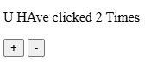
span.textContent = count;
})
function decCount(){
count--;
span.textContent = count;
}
</script>
</body>
</html>

Q3. Create a JS array of color names. In HTML create a div with fixed height and width. Also, create buttons based on array elements. If any button is clicked, the background color of the div should change to the corresponding color.

<!DOCTYPE html>
<html lang="en">
<head>
<meta charset="UTF-8" />
<meta name="viewport" content="width=device-width, initial-scale=1.0" />
<title>Document</title>
</head>
<style>
.page {
width: 100px;
height: 100px;
border: 2px solid black;
}
</style>
<link rel="stylesheet" href="./bootstrap.min.css">
<body>
<div class="container">

<div class="box">
<div class="page">
<!-- <div class="page" name="page"></div> -->
</div>
<div class="buttons">
<!-- <button></button> -->
</div>
<div class="add" onclick="addMore()">
<button>ADD</button>
</div>
</div>
</div>
<script>
let colors = ["red", "green", "blue", "yellow", "pink", "orange"];
let buttons = document.querySelector(".buttons");
for (let c of colors) {
let btn = document.createElement("button");
btn.textContent = c;
buttons.appendChild(btn);
btn.style.backgroundColor = c;
}
function addMore(){
let color = prompt("Enter Color");
colors.push(color);

let col = document.createElement("input");
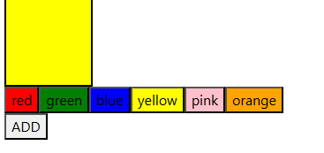
col.type="color";
col.addEventListener("change", (e) => {
colors.push(e.target.value);
})
buttons.appendChild(inp);
}
buttons.addEventListener("click", (e) => {
console.log(e);
console.log(e.target);
if (e.target.tagName === "BUTTON") {
let page = document.querySelector(".page");
page.style.backgroundColor = e.target.textContent;
}
});
</script> <script src="./bootstrap.bundle.min.js"></script>
</body>
</html>
Q4. Create a form to add TODOs with 3 fields – task, date, and time. Each time a task is added it should be displayed on the same HTML page along with the existing tasks. Style the TODOs with Bootstrap. Every TODO will have a “Done” button and once click on Done the respective task should be deleted.

<!DOCTYPE html>
<html lang="en">
<head>
<meta charset="UTF-8">
<meta name="viewport" content="width=device-width, initial-scale=1.0">
<title>Document</title>
<link rel="stylesheet" href="./bootstrap.min.css">
</head>
<body>
<div class="container">
<h2>TODO LIST</h2>
<div class="div">
<input type="text" id="task" class="form-control task" placeholder="Enter ur Task">
<input type="date" id="date" class="form-control task">
<button id="addBtn">ADD</button>
<button id="addList" onclick="addList()">Add To List</button>
</div>
<div>
<ul>
<!-- <li></li> -->
</ul>
</div>
<div class="card" style="width: 18rem;">
<div class="card-header">
Lists
</div>
<ul class="list-group list-group-flush" id="list">
</ul>
</div>
</div>
<script src="./bootstrap.bundle.min.js"></script>
<script>
let addBtn = document.getElementById("addBtn");
let inp = document.querySelector(".task");
addBtn.addEventListener("click", ()=>{
let task = inp.value;
let date = document.querySelector("input[type=date]").value;
let li = document.createElement("li");
li.textContent = task + " " + date;
let ul = document.querySelector("ul");
let btn = document.createElement("button");
btn.textContent="Done";
btn.addEventListener("click",()=>{
li.style.textDecoration="line-through";
})
let btn2 = document.createElement("button");
btn2.textContent="Delete";
btn2.addEventListener("click",()=>{
li.remove();
btn.style.display="none";
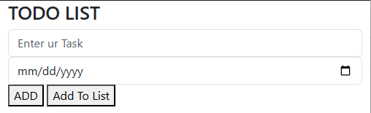
btn2.style.display="none";
})
ul.appendChild(li);
ul.appendChild(btn);
ul.appendChild(btn2);
inp.value="";
inp.focus();
})
</script>
</body>
</html>

